**GOVERNMENT DEGREE COLLEGE, GUMMALAKSHMIPURAM**

**DEPARTMENT OF HISTORY 2024-25**

**Name of the Event: Indira Gandhi and Jhansi laxmi bai Birth anniversary**

**Guest of Honor : Dr T.Sreevaram [Principal]**

**Date                      : 19-11-2024**

**Department               :  History**

**Lecturers Attended: 05**

**Students Attended: 100**

**The department of history Government degree college Gummalakshmipuram, Parvathipuram manyam dist conducted the birth anniversary day of indira Gandhi and Jhansi laxmi bai under the presiveover of Dr T.sreevaram principal on the account of this day.**

**The main aim of the conducting the event in the college is to make the student participate in the even so that they will share their knowledge about the veteran laxmi bai, indira Gandhi first women preministar of India, the great  politician. Jhansi laxmi bai  also known as the rani of Jhansi ,she also regarded as one of the greatest freedom fighters in India .we also remembered both of   them they  sacrifices for the life the event showed the positive impact the student.**

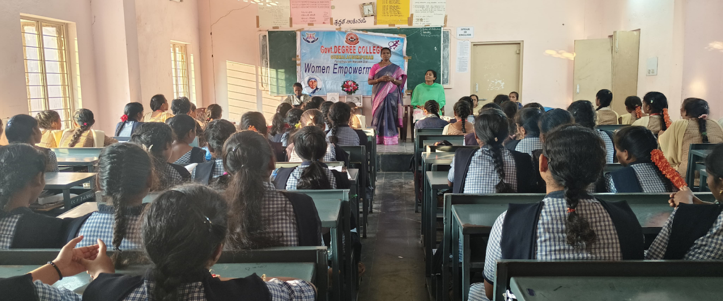 **Principal Madam Delivered Message**

**Indira Gandhi, India’s first and only woman Prime Minister was a leader of remarkable strength and vision. She played a crucial role in shaping modern India through bold decisions like the Green Revolution, which made India self-sufficient in food production, and the 1971 war victory, which led to the creation of Bangladesh. Her leadership in challenging times proved that women are equally capable of leading nations with confidence and determination.**

**Rani Lakshmibai – The Fearless Warrior of JhansiRani Lakshmibai, also known as the Queen of Jhansi, was a symbol of bravery and patriotism. During the 1857 First War of Independence, she fearlessly fought against British rule, refusing to surrender her kingdom. With her infant son tied to her back, she led her army into battle, inspiring generations of Indians with her sacrifice and undying spirit. Her famous words, "Main apni Jhansi nahi dungi" (I will not give up my Jhansi), continue to echo in our hearts.**

**Conclusion: Both Indira Gandhi and Rani Lakshmibai broke barriers and stood as icons of strength, resilience, and patriotism. They remind us that with courage, determination, and the right leadership, women can change the course of history. As students, you must take inspiration from these great women—dream big, work hard, and contribute to society with dedication.**